SHORT TERM CARGO SHIP SAFETY CERTIFICATE

VESSELS UNDER 500 GRT
Under the authority of the Government of

THE MERCHANT MARINE HONDURAS

By GR CLASS CLASSIFIED FOR STANDARD (GR CLASS)

SAFCE No.

Name Ship | Type | Distinctive number or letters | Port of registry | Gross tonnage | Keel laid
 |  | IMO Number:

Authorized for voyages proceeding not further than Miles from shore.

Issued at Date of issue
(Place of issue of certificate) (DD-MM-YYYY)

Issued at Date of issue
(Place of issue of certificate) (DD-MM-YYYY)

The survey has shown that:

- The life-saving appliances provided for a total number of persons and no more, viz:

Lifeboats or rescue boats1 capable of accommodating persons; Motor boats (included in the total shown above);
Liferafts, for which approved launching devices are not required, capable of accommodating persons;

Liferafts, for which approved launching devices are required, capable of accommodating persons;

Lifebuoys

Lifejackets.

- That a Full Term Certificate will be issued accordingly at a later stage.

This provisional certificate remains in force until the full term Cargo Ship Safety Certificate has been delivered on board but not later than
(DD-MM-YYYY)

The undersigned declares that he is duly authorized by the said Government to issue this certificate.

Issued at |  | Date of issue
 | (Place of issue of certificate) | (DD-MM-YYYY)

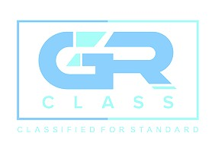

GR CLASS REPRESENTATIVE
1 Delete as appropriate

GR CLASS – CLASSIFIED FOR STANDARD (GR CLASS)
E-mail: info@grclass.com Web: www.grclass.com
Form SAFCE-COND Approved by: GM Page 1 of 1

